Mapping the value stream
Jared Lovelle. IIE Solutions. Norcross: Feb 2001.Vol.33, Iss. 2; pg. 26, 7 pgs

Subjects: Production methods, Value added, Efficiency, Mapping
Classification Codes 9190 United States, 5310 Production planning & control
Locations: United States, US
Author(s): Jared Lovelle
Document types: Cover Story
Publication title: IIE Solutions. Norcross: Feb 2001. Vol. 33, Iss. 2; pg. 26, 7 pgs
Source type: Periodical
ISSN/ISBN: 10851259
ProQuest document ID: 68597087
Text Word Count 3398
Document URL: http://proquest.umi.com/pqdweb?did=68597087&sid=3&Fmt=4&clientId=10342&RQT=309&VName=PQD

Abstract (Document Summary)
This article outlines a tool – value stream mapping (VSM) – that will help industrial engineers enlighten managers who still support obese manufacturing techniques and allow them the see the light of lean manufacturing. VSM is a map that outlines the current and future state of a production system, allowing users to understand where they are and what wasteful acts need to be eliminated. The user then applies lean manufacturing principles to transition into the future state. VSM is an outline of a product's manufacturing life cycle that identifies each step throughout the production process. The overall goal is to move from batch and push to one-piece flow and pull through the entire value stream. The ultimate goal is to design and introduce a lean value stream that optimizes the flow of the entire system - from information, to material, to finished goods arriving at the customer's door.
Full Text (3398 words)
Copyright Institute of Industrial Engineers Feb 2001

COVER STORY

Not too long ago I visited a manufacturing company in hopes of landing that ever-elusive "perfect job" After summarizing my life on six sheets of paper and sweating through a nerve-racking interview, I realized I had survived long enough to enjoy dessert: the plant tour. As I walked down the hall toward the prize, I thought about the questions I had that could only be answered by a personal inspection of the facility. At the end of the hall was a large, gray metal door covered with safety signs and supported by a chipped floor deeply engrained with years of dirt and grime. The door opened and my mind was filled with confusion (plants like this still exist?) and elation (the factory was grouped into huge, singular departments).
Like a patron on a tour in a dark museum, I was led through one monstrous department after another.
I looked in amazement at queued batched loads that were so large they had to be moved by overhead crane. The cloth container holding the batch was massive. Some engineer had undoubtedly spent months convincing management to buy the crane so that twice or even three times the quantity could be moved from one department to the next.
Onward we marched through more segregated work areas, multiple inspection stations, an oversized warehouse stocked wall-to-wall and 50-feet high with finished goods. We traveled through packaging, final inspection, and finally to the shipping dock. All told, I counted 10 separate departments inside two buildings, more than five inspection posts, and more than 12 places to house work-in-process and finished goods inventory.
After the tour, I sat down to lunch with the engineering manager. Although we had talked for almost two hours that day, everything for me hinged on his opinion of lean manufacturing. After several carefully chosen questions, it was clear to me that the manager had no idea that a lean system was needed.

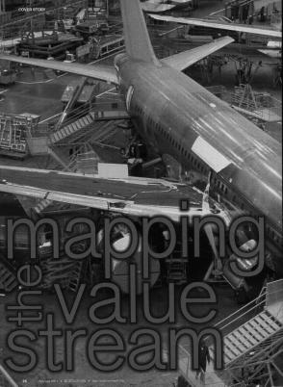 | 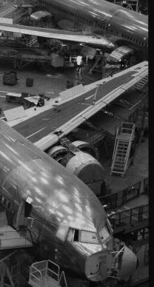 | It seemed he was completely unwilling to change. Although an IE, this gentlemen was caught in the same quagmire that many of our accounting and management co-workers are in - batch and queue mentality. This article outlines a tool – value-stream mapping (VSM) – that will help you enlight-en managers who still support obe-se manufacturing techniques and allow them to see the light of lean manufacturing.

Value-stream mapping
Powerful yet simple, no other tool can outline and distinguish the true value of a product as VSM can. Business cases, payback periods, and other management tools do not necessarily add value to products. However, understanding the proper flow of that product and maximizing value throughout the stream can eliminate many costly errors. The beauty of value-stream mapping is found in its usefulness and simplicity. VSM helps answer the question: How do we continuously improve in a capable, sustainable manner? VSM is a map that outlines the current and future state of a production system, allowing users to understand where they are and what wasteful acts need to be eliminated. The user then applies lean manufacturing principals to transition into the future state.
Promoted and instituted by Toyota Production Systems, VSM immigrated into North America in the 1990s. The true revolution of VSM in the United States can be traced back to only a few years ago with the publication of two books: The Machine That Changed the World and Lean Manufacturing. These works outline the lean manufacturing thought process and describe the critical nature of value-stream mapping to the process.
VSM is a pencil-and-paper tool that helps users see and understand the flow of material and information as products make their way through the value stream. The value stream includes the value-adding and non value-adding activities that are required to bring a product from raw material through delivery to the customer. In other words, VSM is an outline of a products manufacturing life cycle that identifies each step throughout the production process.
Mapping the value stream is a big-picture technique that takes into consideration all processes and seeks to improve the enterprise as a whole. In essence, the map is a simplified visual blueprint that identifies value and waste throughout the system and encourages a systematic approach to eliminating waste.
The overall goal of VSM is to move from batch and push to one-piece flow and pull through the entire value stream. The ultimate goal is to design and introduce a lean value stream that optimizes the flow of the entire system - from information, to material, to finished goods arriving at the customer's door. Lead-time, inventory, and over-production are therefore reduced; throughput, efficiency, and quality are improved.
The current state
Where do we begin this mapping and how does it work? Developing the map requires the user to draw a series of icons, each representing a different stage in the value stream. There are three distinct icon types: material flow, information, and general icons.
Material flow icons represent stops in the manufacturing process (machines, assembly stations), outside sources (factories), inventories, push arrows, truck shipments, etc. Data boxes that display key production metrics accompany material flow icons. Several other material flow and general icons exist. (A complete list of icons is available in "Learning to See," an instruction manual published by the Lean Enterprise Institute of Brookline, Mass.)
Information lines are used to connect material flow icons to form a complete and united production system. The lines represent all types of information flow, including manual, electronic, kanbans, go-see scheduling, and load levelling. Like material flow icons, information lines are accompanied by small, rectangular description boxes. These boxes detail the frequency of the information flow. As is true in most kaizen events, VSM should be conducted in a cross-functional, team setting. The team should include associates from all areas of the company as well as a representative of the customer.
Mapping the value stream always starts with customer demand. But for which product? Your company may produce 400 SKUs. The basis of lean manufacturing is product families. Everything in a lean organization (machines, R&D, marketing, engineering, and even maintenance) is organized around specific product families. Thus, the first task for the mapping team is to define which product family to map. This task in itself may require a new outlook on business and obligate the team to make decisions before inviting the customer in to begin mapping.
- Start the map by drawing a factory icon and data box in the top right corner of the paper (Figure 1). Fill in the data box with a list of customer requirements (remember that the value stream is based upon product families, so be specific) such as units per day, number of shifts, complexity breakout, and other production information. Remember that the scope of a value-stream map encompasses much more than just the factory. It includes the entire value stream from raw material to shipment of finished product. Therefore, the best place to start is with the customer, since the customer is the only individual who can define the true value of the commodity at hand. (The customer icon on the map resembles a castle, representing the fact that the customer is king.)

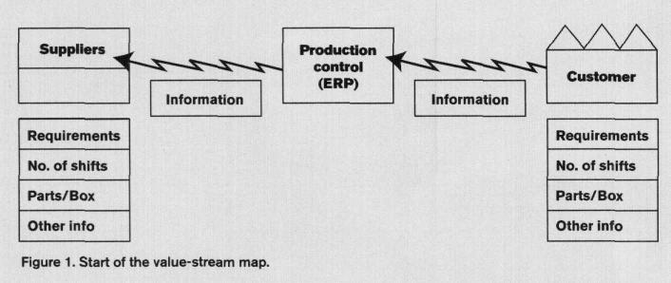
Figure 1

- The next step is outlining the basic supplier production process. Use a process box on the left side of the map to represent suppliers. Usually, all suppliers cannot be listed, so the rule of thumb is to select the supplier of the most vital components or the company that supplies the most components by dollar amount. After the suppliers are drawn, list the production details of the operation in a data box. This information should be readily available from your purchasing department.
- The last step of the external map is to connect all the icons with information flow icons. Draw the appropriate icon based on the type of information flow. Figure 1 has electronic information flow, which is indicated with lines that appear as lightning bolts. Other types of flow make use of different types of lines. Below each information icon, draw a description box and fill in the frequency of information flow. The external map is now complete.

Internal mapping
At this time, stop all mapping activity. The team must make the transition from external to internal mapping. The key to internal mapping is for all members of the team to get out of their chairs and observe production from the floor. Do not take things for granted - verify.
The best place to start is in the shipping department. The team should break into small groups and document the process in reverse order. Working in reverse allows a better understanding of the flow and build of a product. Information needed from the production floor includes all machines, processes, WIP, inventory (raw and finished), and all cycle times within each process. Once the information is collected, the team will reunite and draw the appropriate icons on the bottom of the map.
Once again, start with the shipping department and work backward. Place process boxes on the map (machines, assembly, paint, etc.) whenever processes are disconnected and the flow stops. Add data boxes below each process box and include all the information the team retrieved from the production floor. After drawing the internal process boxes, complete the loop by adding the correct material flow icon from one process to another. One example is a push system with WIP. This is represented with a slashed arrow (Figure 2) and an inventory icon.
Be honest when drawing the current state, especially with WIP and inventory. Many systems are designed to have one-piece flow but in practice, WIP is hidden throughout the process. Draw the current state as it existed when the tour was conducted, not how the system is "supposed to" run. Next, draw a truck shipment from the suppliers to the first internal icon in the bottom left of the map. Repeat the step on the right side for outbound freight. For both icons, write the frequency of shipments in the truck bed and connect the production control system to each process icon with the appropriate flow line.
The last step is to draw a time line under each process box and inventory triangle to outline the production lead-time. The Figure 2 example shows a production lead time of 4.5 days; a value-added time of 3.9 minutes results in a 3.6 percent value-added process. The current state is now finished.

Identify waste
Now that the current state of the value stream has been mapped, waste throughout the stream must be identified and eliminated to shorten lead-time and improve the value-added percentage - in other words, to transform the production system from a batch and push into a one-piece flow and pull. This is truly where the power in VSM lies. VSM allows the user to see the waste throughout the stream and imagine a future state that more closely resembles lean. However, the only way to identify the waste is to understand the seven elements that do not contribute to the value of the product:
- overproduction,
- inventory,
- transportation,
- waiting,
- motion,
- over-processing, and
- correction (re-work).

All seven elements can be identified (if they exist) on the current-state map. Take a look.
Overproduction can be identified with inventory triangles after the last internal process box and before shipment to the customer (overproduction is any inventory at all throughout the entire process). If the triangles exist, determine if the overproduction is the result of a pull requirement (built directly to order and in a "supermarket") or a push requirement (predicting or even guessing what the customer might order and building to the prediction). If the overproduction is pull-oriented, the system is very close to lean. Simply ensure that takt time is being met (and not exceeded) and that the overproduction cannot be eliminated. If the system is push-oriented many questions must be addressed (and that is an entirely different article).
Inventory is identified by the triangle with an "I" in the middle. Inventory is not part of the lean concept, and it kills production lead-time. Lean manufacturing requires one-piece flow throughout the production system. One-piece flow ensures much shorter lead times and problem identification before an entire week's worth of product is manufactured incorrectly. If the machines, layout, and process cannot support one-piece flow, these factors must be investigated and improved. However, do not despair. Lean events often require major changes within a process, and the benefits (improved lead time, floor space reduction, and increased cash flow) greatly outweigh the consequences (losing customers).

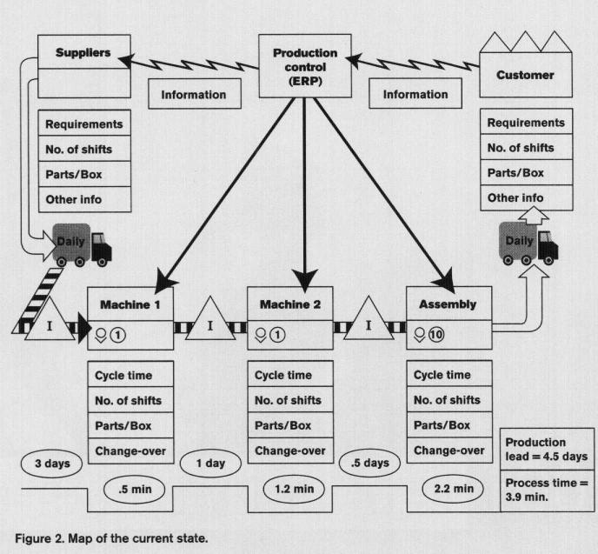
Figure 2.

Transportation is identified by the truck icon and could occur around any inventory location or between process boxes. Transportation, like the other seven wastes, is non-value-adding activity and can, in fact, damage the commodity. Although some transportation may be necessary, it can usually be reduced drastically by using pull systems, one-piece flow, JIT supply chains, and proper plant layout.
Waiting and motion are harder to identify from the current-state map, but signs of these wastes can be found. Waiting and motion exist in a system that is not balanced from one process (internal or external) to another. Conversely, waiting is a double-edged sword in that many companies will overproduce rather than stop production and wait for the pull signal from the pace-maker. Implementing a balanced, one-piece flow system complete with 5S, total productive maintenance, and visual management can minimize waiting and force elimination of wasted motion.
Over-processing occurs when complex solutions are applied to simple situations. An example is using a large, inflexible machine instead of a smaller, highly adjustable one. The large machine usually requires cost justification, so production is increased to maintain the payback period, which increases inventory. Overprocessing can be found in the current-state map by examining the internal process icons at the bottom of the page. If the product family is somewhat complex and yet a very small number of process icons exist (and inventory icons exist between processes), this is a good clue that there is overprocessing. However, the best clue is long set-up times that can be found in data boxes beneath the process icons.
Correction or re-work almost always causes flow to stop. Consequently, if the current state is mapped honestly, re-work should be represented by an inventory icon (for backlog of re-work) or an actual process box. Re-work is truly non-valueadding and is caused by poor work methods and a lack of problem-solving. The transition from an obese to a lean manufacturing system requires everyone to solve problems and make changes. This is where the future state and action plans are critical for success.

The future state
The future-state map is easy to develop but requires determination and persistence to implement. This said, the development of the future-state map is critical to provide a blueprint to the ideal state of lean. There is a method to developing the future state.
The first step requires the calculation of takt time. Takt time is the number of units required by the customer per unit of time. To calculate takt time, use the following formula: takt time = (net operating time / period) / (customer requirements / period). Note that takt time is not cycle time. However, for a lean process, cycle time plus a small efficiency standard should equal takt time.
The importance of takt time lies in the goal of producing one unit just in time to replace a unit used by the customer - in other words, a cycle time based on one-piece flow. If cycle time exceeds takt time, the process will generate WIP, waiting, excess motion, damage, and other waste. Again, changes inside departments, machine cells, and warehouses most likely will be required to promote one-piece flow and ensure that takt time is met.
Reducing cycle time and creating one-piece flow leads into the next future state question: Where can the production system use continuous flow? An example of continuous flow is an automated assembly line. The automation forces one-piece, continuous flow. True, the line most likely can be stopped - since continuous flow does not imply 100 percent efficiency - but the nature of the automation forces line support and engineers to balance the operation and ensure continuous flow. Additionally, the continuous flow can proceed at a pace that guarantees takt time will be met. WIP, excess waiting, material handling, and over-processing are eliminated with continuous flow,
Several techniques are available to aid the implementation of these lean manufacturing principals. These include teamwork, 5S, kaizen events, total productive maintenance (TPM), and visual management. Of these, TPM and visual management are critical for implementation of one-piece, continuous flow TPM is a system that integrates production workers into the preventive maintenance program, empowering workers to address and maintain the equipment they use each day to improve efficiency and reduce downtime. TPM is accomplished when the maintenance technicians train the operators who use the equipment. The technicians outline the tasks each party is responsible for, enabling the operators to maintain equipment and keep the line running. Allowing operators to accept ownership relieves skilled maintenance technicians of daily repetitive tasks so they can concentrate on predictive maintenance.
Visual management is a technique that makes production activities apparent. Visual management also makes defects and waste obvious so that they cannot be ignored. We know that problems exist in every production system; in a lean organization, these problems are easily identifiable. Identification leads to problem-solving before quality suffers. Obese production systems cannot respond to quality concerns with permanent corrective action as quickly and concisely as lean organizations. TPM and visual management are critical for the implementation of continuous flow.

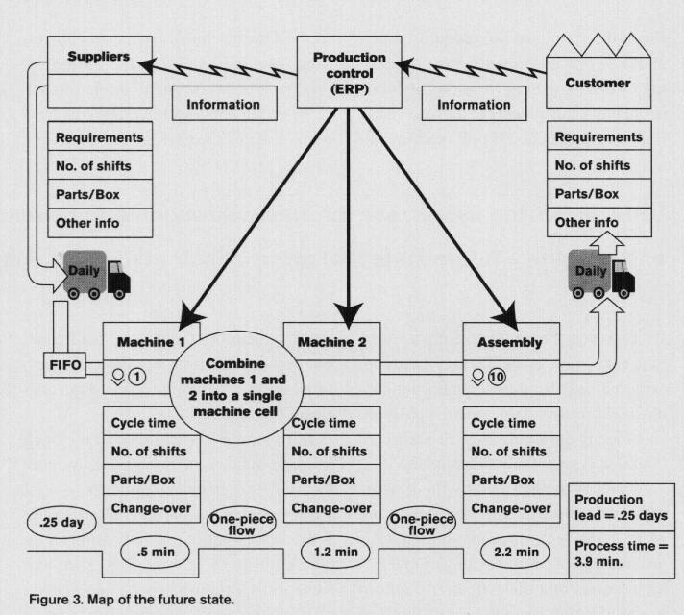
Figure 3.

There are two more questions that must be answered before drawing the future state: Where in the production system do we trigger production? and How do we level the production mix? Answering these questions and attacking the seven wastes produces the basis for a future-state map. After these questions have been answered, draw the map implementing the changes to be made. Remember, the future state describes how things could be (a lean flow), not how they are. Be very creative and challenge each other. The resulting future state does not mean it is the final future state. Once the future state is drawn, analyze the waste throughout the process and re-evaluate the map. Repeat this process as necessary during the event and over time after the event. An example of a future-state map can be found in Figure 3.
After the future-state map has been developed, an action plan and extended value stream plan must follow. An action plan is created to make the transition from the current state to the future state. Simply itemize the differences between the two maps and create an action list. If this is the first VSM event in your company, direct the action plan at the location for which success is highly likely. Doing this will encourage the team and promote an aggressive attitude that will be needed for the tougher action items.
The extended value stream plan involves kaizen and re-evaluation of the future state once it has been implemented. The extended plan will also involve redefining the metrics used to evaluate the production system. This plan involves expanding the mapping events to all product families within an organization. Once this is accomplished, start working on VSM with suppliers. Huge amounts of waste can be eliminated through collaboration or joint ventures.
Value-stream mapping is a communication tool, a business planning tool, and a tool to manage the extended enterprise. The backbone of VSM is management buy-in and support based on product families. VSM, if used property, allows all stages of a product's life to bond, creating an entity that flows through an efficient production system like water through a fire hose. VSM, like lean manufacturing, has a bright and powerful future and will continue to reshape manufacturing systems throughout the world. *

For further reading (See page 65 for ordering information.) Womack,J. P and D. T Jones, Lean Thinkin, Simon & Schuster Trade.
Womack, James .P , Daniel T. Jones, au Daniel Roos, The Machine That Change the World, HarperTrade.

Author
Jared Lovelle is an industrial engineer for Textron Automotive Co., a division of Textron Inc., in Oklahoma City, Okla. He is responsible for lean manufacturing and continuous improvement coordination. Lovelle is also responsible for new project development and error-proofing. He has a B.S. in industrial engineering from the University of Oklahoma.

Copyright © 2005 ProQuest Information and Learning Company. All rights reserved.


